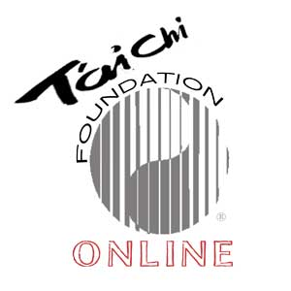
Tai Chi from the Beginning
“Tai Chi Chuan, the great ultimate, strengthens the weak raises the sick, invigorates the debilitated, and encourages the timid." Cheng Man-ch’ing

WHAT: Introduction to T’ai Chi - 1st Third of Yang Style Short Form
Tai chi movements are widely acknowledged to help calm the emotions, focus the mind, and strengthen the immune system. Practiced at a slow and even speed, tai chi promotes relaxation, straight posture, and balance. In a very real sense, tai chi helps us to stay younger as we grow older, thus making an outstanding contribution to our overall health and well-being.
WHEN: 12 LESSONS, Fill in your own info.
COST: $10 per class. Class payments are made at the start of every 4-classes. Preferred payment methods are Venmo, Paypal + Check. Join the first class, try it out before purchasing 1st 4-pack series. Note: Repeating students are free for the series.

New Class Series Starts : Tuesday Oct 6th
TEACHERS: Fill in your own info.
Sign Up with Zoom Registration Link Here
For additional information: email Fill in your own info.
Enrollment open for Fill in your own info.

